**Cage Design Protocol**

**Padilla-Gamiño Lab**  
School of Aquatic and Fishery Sciences  
University of Washington

Written by Lindsay Alma and Courtney Fiamengo--June 2017

1. Acquire mesh “**oyster bags**.” They are not sealed initially. You need wire cutters or **strong scissors** to cut a triangle shape off of the end of each corner. Each triangle must be the same size (triangle sides should be ~5 in). You can use a **carpenter triangle** to measure. (Note marking the sides of the triangle makes it easier.) 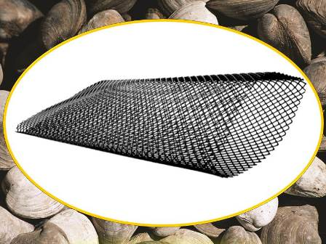
2. After the corners are cut, you seal the bag by folding one edge of the bag inside and the other over the top. Make sure the corners of the bag meet so there are no large holes where organisms could get out. Use strong **zip ties** to hold the bags shut.
3. Insert two 2 in spacers (pieces of PVC pipe) into the middle of the bag holding it in place with zip ties. This is to leave space in the bag for the organisms.
4. Use **measuring tape** to measure the oyster bags. This will give you dimensions for the cages.

* The “Oyster bags” were 20.5 in by 39.5 (before folding). There were 2 in spacers in the bags and 6 bags.

1. For the top of the cages:

* You will need these **fittings**: 5 elbows, 2 crosses, and 1 “T”
* Width: Four 10 in PVC pipes; Length: One 18 in PVC pipe, and two 5 in PVC pipes 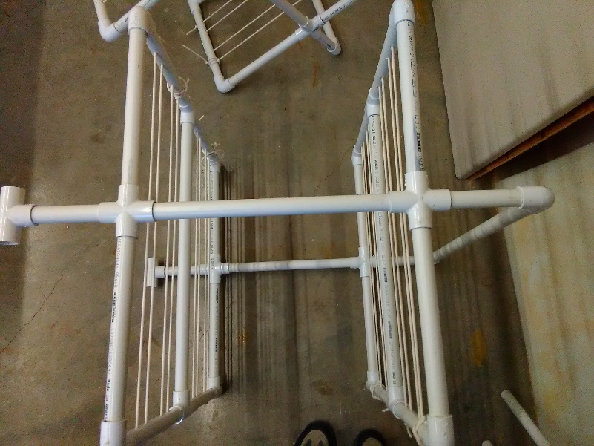

1. For the Bottom: 1. Hanging Cages- same as top; 2. Fixed cages (with legs) described here:

* You will need these fittings: 5 T’s, 2 crosses, 1 elbow
* Width: Four 10 in PVC pipes; Length: One 18 in PVC pipe, and two 5 in PVC pipes

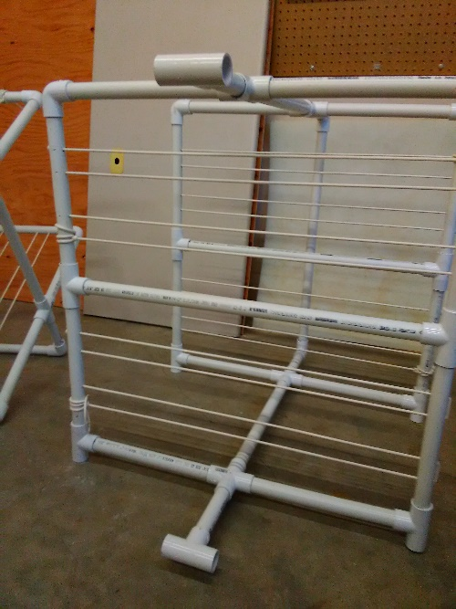

1. For the middle section/ height of cage

* You will need 4 “T’s” and two 11 in PVC pipes, and four 7 in pipes

1. For better spacing, holes should be drilled into the PVC pipe for wire to be weaved through the pipe. The intent is to create 2 in pockets for the “oyster bags” to slide in with 1 in spacing in between the bags.

*Note: When measuring length/width to decide how long the PVC pipe should be, don’t forget to take into account the length of the fittings because this will make a difference.

*Also, if you put the cages together without the glue to see if they are the right size, remember the PVC glue helps that pipe slide further into the fittings so it will be slightly tighter. It is better to be a little too big.

**¾ in PVC pipe** was used

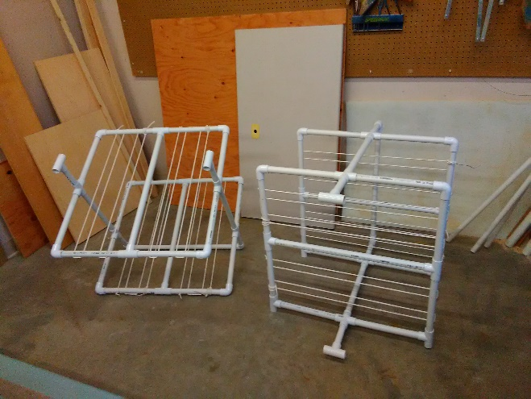

1. Bungee cord was hooked around the two “T’s” to close the cages/ hold the bags in place. A large zip tie was used to loop though three bags for collection.

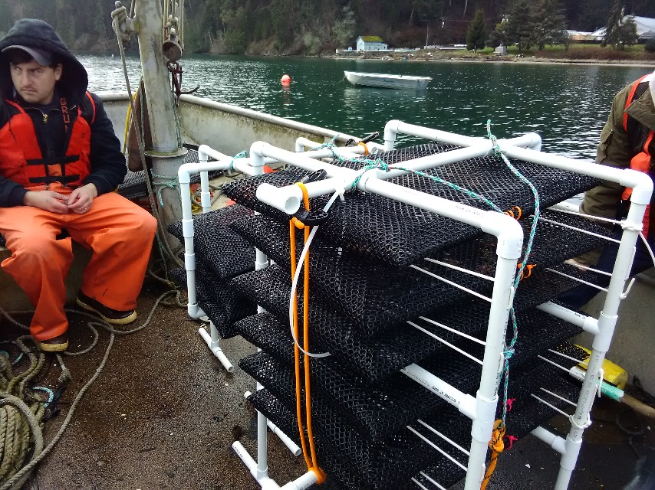

1. “Legs” will be added to the “T’s” on the bottom of the Fixed Cages.

* To add legs, you need 4 “T’s”, four 12 in PVC pipes, and eight 6 in PVC pipes

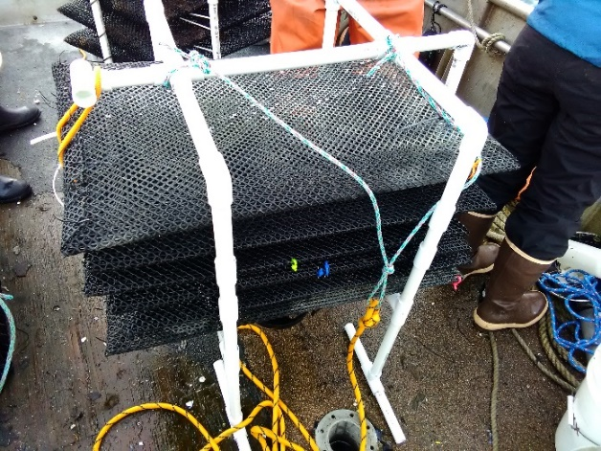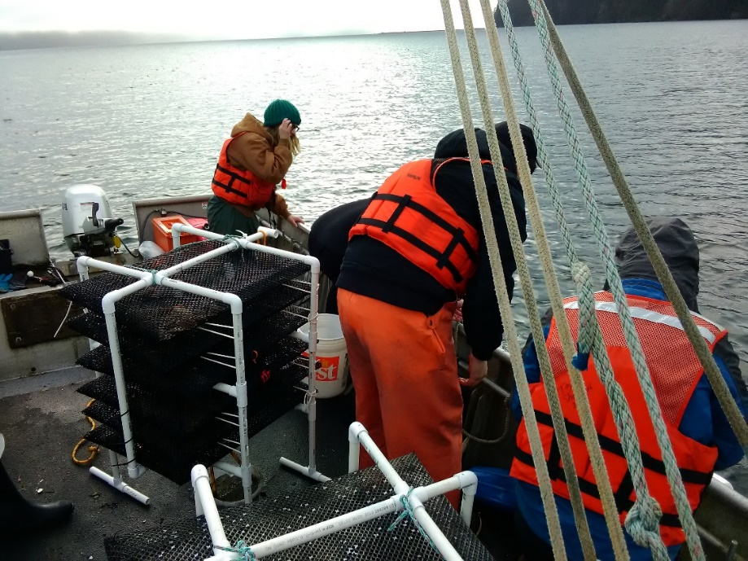

1. Cement anchor can be made to weigh down the cages.

* Buy a small bucket. Tie a rope to form a loop large enough to have the knot touching the bottom of the bucket and the rest of the rope come out above the bucket to make a handle.
* Dump cement and stir in water making sure the handle stays above the cement but deep inside. You will need strong rope for this.

